Supplementary Materials

pK_{a} Prediction for Acidic Phosphorus-Containing Compounds Using Multiple Linear Regression with Computational Descriptors
Donghai Yu, Ruobing Du, Ji-Chang Xiao*
Key Laboratory of Organofluorine Chemistry, Shanghai Institute of Organic Chemistry, Chinese Academy of Sciences, 345 Lingling Road, Shanghai 200032, China.
Fax: (+86) 21-6416-6128; Tel: (+86) 21-5492-5340; E-mail: jchxiao@sioc.ac.cn
Contents
Table S1. The Structures of acidic phosphorus-containing molecules. S1
Table S2. The structure parameters of all structure. S8
Table S3. Correlational analyses between structure parameters of training set. S16
Table S4. MLR results of parameters collected in Table 1 S18
Table S5. The best results of MLR. S18
Complete Gaussian 09 reference (Ref. 35) S19

Table S1. The Structures of acidic phosphorus-containing molecules.
No. | Structure | IUPAC name | pKa (Expt.) | Ref.
1 | 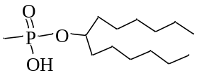 | methylphosphonic acid mono-1-hexylheptyl ester | 4.20 | 22
2 | 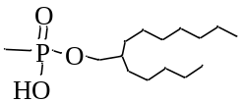 | methylphosphonic acid mono-2-pentylnonyl ester | 3.98 | 22
3 | 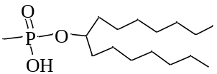 | methylphosphonic acid mono-1-heptyloctyl ester | 4.20 | 22
4 | 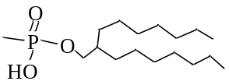 | methylphosphonic acid mono-2-heptylnonyl ester | 3.98 | 22
5 | 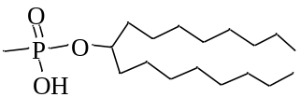 | methylphosphonic acid mono-1-octylnonyl ester | 4.20 | 22
6 | 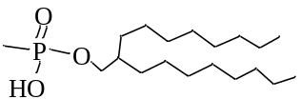 | methylphosphonic acid mono-2-octyldecyl ester | 3.95 | 22
7 | 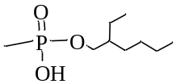 | methylphosphonic acid mono-2-ethylhexyl ester | 3.95 | 22
8 | 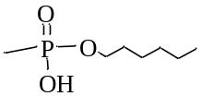 | methylphosphonic acid mono-hexyl ester | 3.85 | 22
9 | 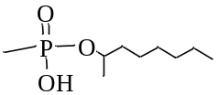 | methylphosphonic acid mono-1-methylheptyl ester | 4.10 | 22
10 | 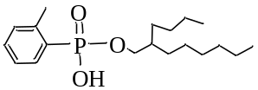 | o-methylphenylphosphonic acid mono-2-butyloctyl ester | 3.82 | 27
11 | 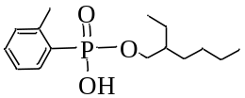 | o-methylphenylphosphonic acid mono-2-ethylhexyl ester | 3.68 | 22
12 | 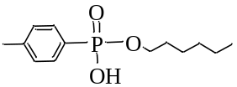 | p-methylphenylphosphonic acid mono-hexyl ester | 3.51 | 22
13 | 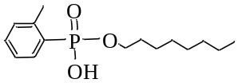 | o-methylphenylphosphonic acid mono-octyl ester | 3.60 | 22
14 | 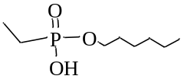 | ethylphosphonic acid mono-hexyl ester | 4.10 | 22
15 | 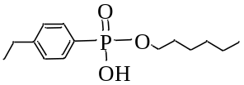 | p-ethylphenylphosphonic acid mono-hexyl ester | 3.54 | 22
16 | 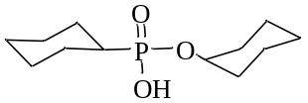 | cyclohexylphosphonic acid mono-cyclohexyl ester | 4.68 | 21
17 | 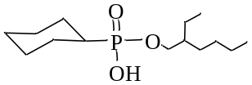 | cyclohexylphosphonic acid mono-2-ethylhexyl ester | 4.55 | 22
18 | 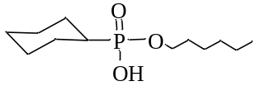 | cyclohexylphosphonic acid mono-hexyl ester | 4.42 | 22
19 | 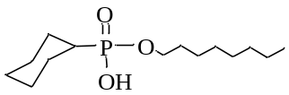 | cyclohexylphosphonic acid mono-octyl ester | 4.40 | 22
20 | 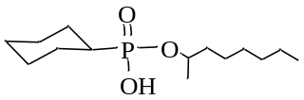 | cyclohexylphosphonic acid mono-1-methylheptyl ester | 4.75 | 22
21 | 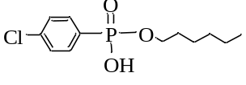 | p-chlorophenylphosphonic acid mono-hexyl ester | 3.12 | 22
22 | 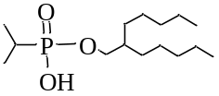 | i-propylphosphonic acid mono-2-pentylheptyl ester | 4.40 | 22
23 | 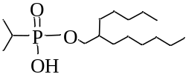 | i-propylphosphonic acid mono-2-pentyloctyl ester | 4.40 | 1
24 | 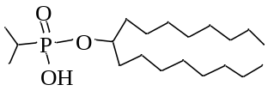 | i-propylphosphonic acid mono-1-octylnonyl ester | 4.48 | 1
25 | 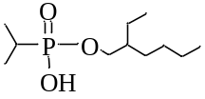 | i-propylphosphonic acid mono-2-ethylhexyl ester | 4.33 | 21
26 | 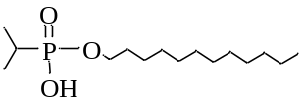 | i-propylphosphonic acid mono-dodecyl ester | 4.20 | 21
27 | 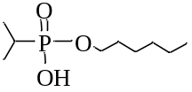 | i-propylphosphonic acid mono-hexyl ester | 4.47 | 22
28 | 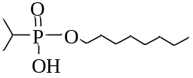 | i-propylphosphonic acid mono-octyl ester | 4.19 | 21
29 | 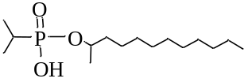 | i-propylphosphonic acid mono-1-methylundecyl ester | 4.22 | 1
30 | 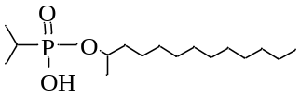 | i-propylphosphonic acid mono-1-methyldodecyl ester | 4.59 | 21
31 | 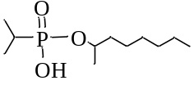 | i-propylphosphonic acid mono-1-methylheptyl ester | 4.60 | 21
32 | 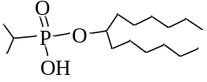 | i-propylphosphonic acid mono-1-hexylheptylester | 4.85 | 21
33 | 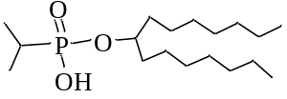 | i-propylphosphonic acid mono-1-heptyloctyl ester | 4.83 | 21
34 | 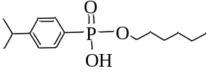 | p-isopropylphenylphosphonic acid mono-hexyl ester | 3.53 | 22
35 | 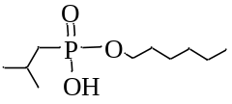 | i-butylphosphonic acid mono-hexyl ester | 4.37 | 22
36 | 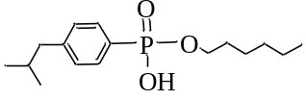 | p-isobutylphenylphosphonic acid mono-hexyl ester | 3.53 | 22
37 | 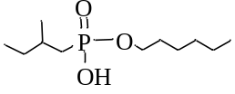 | 2-methylbutylphosphonic acid mono-hexyl ester | 4.27 | 22
38 | 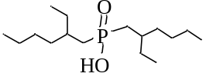 | di(2-ethylhexyl)phosphinic acid | 5.41 | 21
39 | 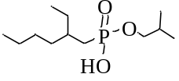 | 2-ethylhexylphosphonic acid mono-2-methylpropyl ester | 4.37 | 21
40 | 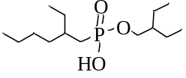 | 2-ethylhexylphosphonic acid mono-2-ethylbutyl ester | 4.40 | 22
41 | 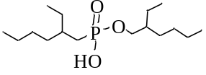 | 2-ethylhexylphosphonic acid mono-2-ethylhexyl ester | 4.50 | 22
42 | 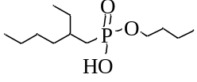 | 2-ethylhexylphosphonic acid mono-butyl ester | 4.27 | 21
43 | 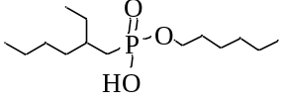 | 2-ethylhexylphosphonic acid mono-hexyl ester | 4.45 | 22
44 | 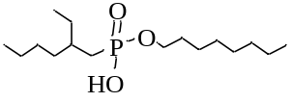 | 2-ethylhexylphosphonic acid mono-octyl ester | 4.33 | 22
45 | 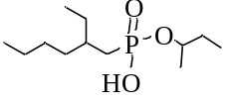 | 2-ethylhexylphosphonic acid mono-1-methylpropyl ester | 4.60 | 22
46 | 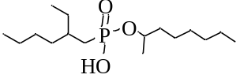 | 2-ethylhexylphosphonic acid mono-1-methylheptyl ester | 4.26 | 25
47 | 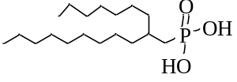 | 2-heptylundecylphosphonic acid | 4.13 | 24
48 | 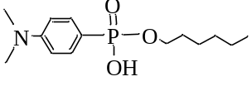 | p-nitrophenylphosphonic acid mono-hexyl ester | 4.05 | 22
49 | 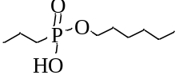 | propylphosphonic acid mono-hexyl ester | 4.20 | 22
50 | 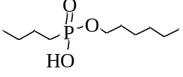 | butylphosphonic acid mono-hexyl ester | 4.26 | 22
51 | 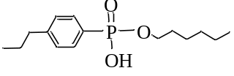 | p-propylphenylphosphonic acid mono-hexyl ester | 3.53 | 22
52 | 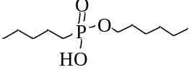 | pentylphosphonic acid mono-hexyl ester | 4.26 | 22
53 | 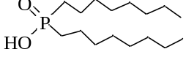 | octylphosphonic acid mono-octyl ester | 5.32 | 21
54 | 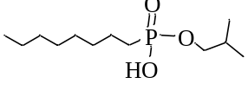 | octylphosphonic acid mono-isobutyl ester | 4.30 | 22
55 | 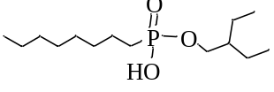 | octylphosphonic acid mono-2-ethylbutyl ester | 4.30 | 22
56 | 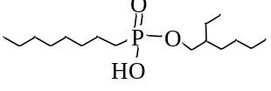 | octylphosphonic acid mono-2-ethylhexyl ester | 4.31 | 22
57 | 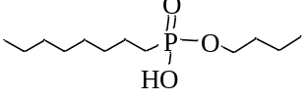 | octylphosphonic acid mono-butyl ester | 4.20 | 22
58 | 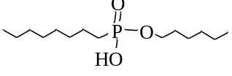 | octylphosphonic acid mono-hexyl ester | 4.25 | 22
59 | 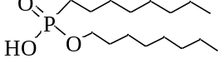 | octylphosphonic acid mono-octyl ester | 4.21 | 22
60 | 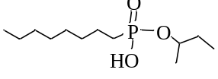 | octylphosphonic acid mono-1-methylpropyl ester | 4.35 | 21
61 | 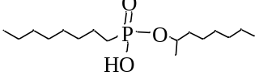 | octylphosphonic acid mono-1-methylheptyl ester | 4.54 | 22
62 | 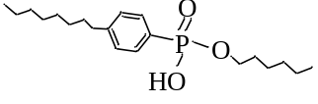 | p-ocylphenylphosphonic acid mono-hexyl ester | 3.53 | 22
63 | 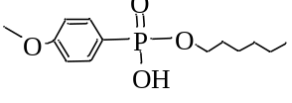 | p-methoxyphenylphosphonic acid mono-hexyl ester | 3.60 | 22
64 | 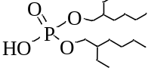 | di(2-ethylhexyl) phosphoric acid | 3.24 | 21
65 | 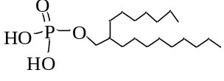 | 2-heptylundecylphosphoric acid | 3.60 | 24
66 | 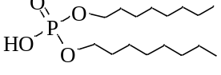 | dioctyl phosphoric acid | 3.05 | 22
67 | 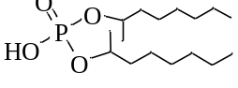 | di(1-methylheptyl) phosphoric acid | 3.75 | 22
68 | 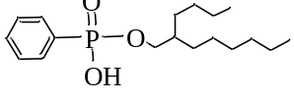 | phenylphosphonic acid mono-2-butyloctyl ester | 3.55 | 27
69 | 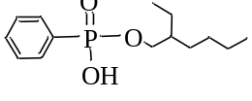 | phenylphosphonic acid mono-2-ethylhexyl ester | 3.53 | 22
70 | 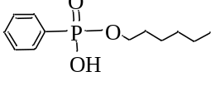 | phenylphosphonic acid mono-hexyl ester | 3.43 | 22
71 | 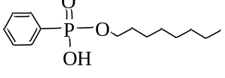 | phenylphosphonic acid mono-octyl ester | 3.43 | 22
72 | 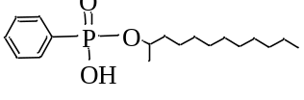 | phenylphosphonic acid mono-1-methylundecyl ester | 3.74 | 27
73 | 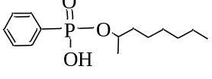 | phenylphosphonic acid mono-1-methylheptyl ester | 3.61 | 26
74 | 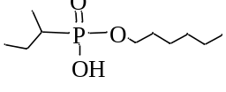 | 1-methylpropylphosphonic acid mono-hexyl ester | 4.43 | 28
75 | 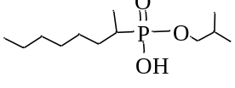 | 1-methylheptylphosphonic acid mono-2-methylpropyl ester | 4.38 | 21
76 | 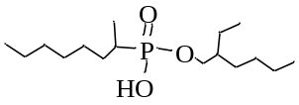 | 1-methylheptylphosphonic acid mono-2-ethylhexyl ester | 4.32 | 25
77 | 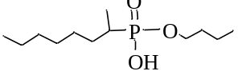 | 1-methylheptylphosphonic acid mono-butyl ester | 4.31 | 22
78 | 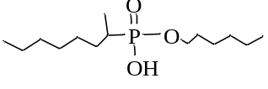 | 1-methylheptylphosphonic acid mono-hexyl ester | 4.60 | 22
79 | 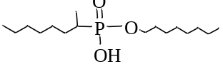 | 1-methylheptylphosphonic acid mono-octyl ester | 4.50 | 22
80 | 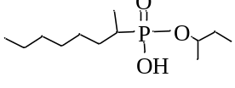 | 1-methylheptylphosphonic acid mono-1-methylpropyl ester | 4.71 | 22
81 | 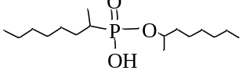 | 1-methylheptylphosphonic acid mono-1-methylheptyl ester | 4.71 | 22
82 | 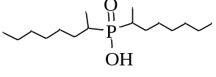 | di(1-methylheptyl)phosphinic acid | 5.85 | 22
83 | 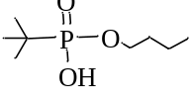 | t-butylheptylphosphonic acid mono-butyl ester | 4.62 | 22
84 | 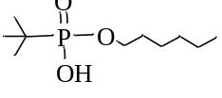 | t-butylheptylphosphonic acid mono-hexyl ester | 4.70 | 22
85 | 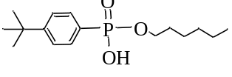 | t-butylphenylphosphonic acid mono-hexyl ester | 3.54 | 22
86 | 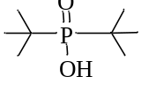 | di(t-butyl)phosphinic acid | 6.09 | 22
87 | 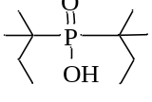 | di(t-pentyl)phosphinic acid | 6.26 | 22
88 | 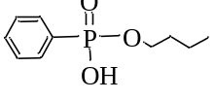 | phenylphosphonic acid mono-butyl ester | 2.53 | 23
89 | 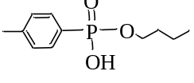 | p-methylphenylphosphonic acid mono-butyl ester | 2.64 | 23
90 | 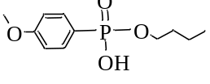 | p-methoxyphenylphosphonic acid mono-butyl ester | 2.70 | 23
91 | 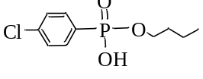 | p-chlorophenylphosphonic acid mono-butyl ester | 2.28 | 23
92 | 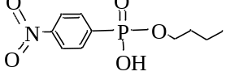 | p-nitrophenylphosphonic acid mono-butyl ester | 1.88 | 23
93 | 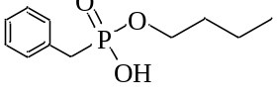 | benzylphosphonic acid mono-butyl ester | 2.87 | 23
94 | 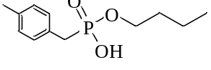 | p-methylbenzylphosphonic acid mono-butyl ester | 3.05 | 23
95 | 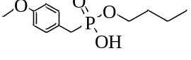 | p-methoxybenzylphosphonic acid mono-butyl ester | 2.99 | 23
96 | 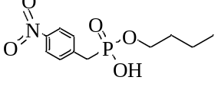 | p-nitrobenzylphosphonic acid mono-butyl ester | 2.39 | 23

Table S2. The structure parameters of all structure.
No. | Q_{E,1} | Q_{E,2} | Q_{E,3} | Q_{E,4} | Q_{E,5} | Q_{E,6} | Q_{M,1}
1 | 0.464981 | -0.705612 | 1.199372 | -0.774345 | -0.537103 | -0.501359 | 0.299279
2 | 0.436239 | -0.632378 | 1.138877 | -0.743908 | -0.366292 | -0.595538 | 0.298468
3 | 0.417586 | -0.596151 | 1.148086 | -0.761632 | -0.503566 | -0.401984 | 0.301808
4 | 0.450603 | -0.636047 | 1.115838 | -0.757650 | -0.453681 | -0.429513 | 0.302056
5 | 0.425616 | -0.616896 | 1.218651 | -0.758521 | -0.575620 | -0.581066 | 0.299995
6 | 0.448049 | -0.656625 | 1.175091 | -0.767262 | -0.468515 | -0.535115 | 0.299931
7 | 0.446334 | -0.655552 | 1.218278 | -0.777075 | -0.481486 | -0.573646 | 0.300283
8 | 0.428042 | -0.621371 | 1.155093 | -0.760696 | -0.507037 | -0.529259 | 0.299677
9 | 0.434002 | -0.593198 | 0.934433 | -0.724703 | -0.495298 | 0.129674 | 0.302939
10 | 0.434068 | -0.560007 | 0.930793 | -0.704223 | -0.367173 | -0.225521 | 0.300656
11 | 0.466763 | -0.628868 | 0.938775 | -0.716988 | -0.457460 | -0.146804 | 0.302349
12 | 0.432729 | -0.593384 | 0.885351 | -0.679752 | -0.499804 | -0.045763 | 0.298535
13 | 0.428321 | -0.559456 | 0.916372 | -0.678786 | -0.470762 | -0.184993 | 0.301805
14 | 0.424456 | -0.603266 | 1.083270 | -0.748257 | -0.575560 | -0.125993 | 0.301318
15 | 0.444016 | -0.601338 | 0.872609 | -0.668126 | -0.472054 | -0.087669 | 0.298101
16 | 0.454862 | -0.626840 | 0.900005 | -0.718411 | -0.553701 | -0.047139 | 0.298838
17 | 0.441351 | -0.632581 | 1.068201 | -0.739645 | -0.475818 | -0.239208 | 0.298051
18 | 0.454291 | -0.653578 | 1.107707 | -0.765738 | -0.547453 | -0.345088 | 0.299305
19 | 0.468648 | -0.666143 | 1.006208 | -0.749140 | -0.377162 | -0.324002 | 0.304092
20 | 0.450165 | -0.627483 | 0.934399 | -0.725291 | -0.479652 | -0.024490 | 0.299221
21 | 0.437558 | -0.593116 | 0.881140 | -0.672932 | -0.490691 | -0.020228 | 0.300301
22 | 0.442976 | -0.609643 | 0.942848 | -0.725951 | -0.456420 | -0.143626 | 0.303077
23 | 0.468353 | -0.710681 | 1.093694 | -0.776687 | -0.578407 | 0.147463 | 0.299343
24 | 0.442097 | -0.610424 | 0.933395 | -0.720867 | -0.406363 | -0.100067 | 0.300114
25 | 0.457096 | -0.652146 | 0.999721 | -0.728819 | -0.378836 | 0.112711 | 0.298409
26 | 0.444801 | -0.654653 | 1.187802 | -0.773784 | -0.549626 | -0.524861 | 0.298766
27 | 0.463578 | -0.636283 | 0.839174 | -0.713995 | -0.327412 | 0.162012 | 0.300226
28 | 0.434602 | -0.594775 | 0.933792 | -0.724038 | -0.494803 | 0.145748 | 0.302896
29 | 0.450482 | -0.621481 | 0.873944 | -0.720101 | -0.430022 | 0.152366 | 0.298477
30 | 0.442583 | -0.616059 | 0.954476 | -0.737960 | -0.398310 | 0.289482 | 0.303571
31 | 0.436003 | -0.620720 | 1.152982 | -0.761157 | -0.553208 | -0.444453 | 0.303387
32 | 0.467976 | -0.712737 | 1.108243 | -0.775328 | -0.572400 | 0.133444 | 0.299493
33 | 0.484654 | -0.738151 | 1.102573 | -0.786788 | -0.580309 | 0.165010 | 0.300530
34 | 0.433076 | -0.583329 | 0.861263 | -0.676193 | -0.485654 | -0.060561 | 0.298082
35 | 0.429494 | -0.615455 | 1.136473 | -0.755399 | -0.517779 | -0.474143 | 0.301920
36 | 0.447961 | -0.611971 | 0.904884 | -0.688768 | -0.436413 | -0.110087 | 0.299781
37 | 0.425354 | -0.621384 | 1.214996 | -0.763906 | -0.506666 | -0.636375 | 0.301779
38 | 0.456593 | -0.700976 | 1.112989 | -0.783502 | -0.308647 | -0.488436 | 0.298835
39 | 0.434684 | -0.621607 | 1.211024 | -0.777554 | -0.525500 | -0.460466 | 0.303818
40 | 0.442913 | -0.607675 | 0.926130 | -0.720779 | -0.451998 | -0.118535 | 0.300560
41 | 0.459152 | -0.708198 | 1.320223 | -0.800483 | -0.487026 | -0.514737 | 0.300039
42 | 0.421432 | -0.603926 | 1.127347 | -0.755712 | -0.498160 | -0.358941 | 0.301503
43 | 0.432156 | -0.625695 | 1.153958 | -0.751099 | -0.501427 | -0.586575 | 0.298254
44 | 0.427031 | -0.624438 | 1.176666 | -0.748559 | -0.501213 | -0.611291 | 0.301432
45 | 0.436095 | -0.602755 | 0.979337 | -0.735015 | -0.454099 | -0.092136 | 0.302935
46 | 0.426771 | -0.610708 | 1.204605 | -0.773898 | -0.526072 | -0.463122 | 0.303746
47 | 0.462298 | -0.686499 | 1.102586 | -0.751275 | -0.565550 | -0.149861 | 0.296396
48 | 0.430573 | -0.606347 | 0.882603 | -0.682579 | -0.500820 | -0.106565 | 0.295311
49 | 0.420444 | -0.594680 | 1.057177 | -0.741219 | -0.520106 | -0.350477 | 0.301258
50 | 0.413140 | -0.597719 | 1.151769 | -0.757549 | -0.530082 | -0.442757 | 0.301336
51 | 0.433620 | -0.592459 | 0.882451 | -0.677540 | -0.497852 | -0.060294 | 0.298761
52 | 0.443022 | -0.638960 | 1.078985 | -0.746541 | -0.448438 | -0.358500 | 0.298562
53 | 0.449190 | -0.678049 | 0.991792 | -0.756982 | -0.372056 | -0.227867 | 0.298189
54 | 0.426776 | -0.617932 | 1.163114 | -0.764196 | -0.508363 | -0.356570 | 0.301375
55 | 0.426929 | -0.618099 | 1.118056 | -0.751775 | -0.451634 | -0.350261 | 0.300057
56 | 0.445987 | -0.616243 | 0.944123 | -0.723362 | -0.430786 | -0.039983 | 0.302869
57 | 0.412630 | -0.610260 | 1.095039 | -0.758021 | -0.522439 | -0.503429 | 0.296846
58 | 0.411500 | -0.589526 | 1.126828 | -0.755072 | -0.543463 | -0.371801 | 0.301645
59 | 0.441734 | -0.619831 | 1.056785 | -0.748923 | -0.429423 | -0.405932 | 0.301147
60 | 0.441401 | -0.605094 | 0.930596 | -0.715617 | -0.320691 | 0.093040 | 0.301045
61 | 0.432359 | -0.629259 | 1.150451 | -0.766403 | -0.584243 | -0.320823 | 0.300749
62 | 0.428278 | -0.582422 | 0.878493 | -0.681259 | -0.477041 | -0.043371 | 0.298295
63 | 0.439497 | -0.585200 | 1.161051 | -0.713655 | -0.323851 | -0.641525 | 0.299585
64 | 0.426236 | -0.598709 | 1.320479 | -0.765497 | -0.460371 | -0.482583 | 0.304878
65 | 0.430084 | -0.589751 | 0.918748 | -0.695292 | -0.486862 | -0.137852 | 0.297771
66 | 0.418594 | -0.578953 | 1.231293 | -0.762769 | -0.491465 | -0.491673 | 0.304557
67 | 0.438793 | -0.630267 | 1.285743 | -0.755555 | -0.530792 | -0.532254 | 0.303707
68 | 0.467395 | -0.638427 | 0.874995 | -0.698359 | -0.398199 | -0.044524 | 0.301248
69 | 0.449098 | -0.616430 | 0.876092 | -0.675503 | -0.465430 | -0.035368 | 0.299385
70 | 0.430730 | -0.579661 | 0.855598 | -0.672275 | -0.490062 | -0.016171 | 0.299166
71 | 0.429710 | -0.577541 | 0.879957 | -0.685744 | -0.474644 | -0.035488 | 0.298986
72 | 0.445351 | -0.618083 | 0.893930 | -0.685302 | -0.532141 | -0.024777 | 0.297455
73 | 0.448019 | -0.626464 | 0.910872 | -0.687888 | -0.526518 | -0.040559 | 0.298447
74 | 0.436811 | -0.591659 | 0.902364 | -0.722795 | -0.451709 | -0.058848 | 0.303542
75 | 0.446365 | -0.626142 | 1.005751 | -0.729055 | -0.477207 | -0.069408 | 0.304147
76 | 0.454108 | -0.625197 | 0.882845 | -0.719716 | -0.390661 | 0.175718 | 0.300254
77 | 0.441307 | -0.615874 | 0.990282 | -0.733839 | -0.435937 | -0.077352 | 0.301366
78 | 0.454323 | -0.674020 | 1.297560 | -0.799103 | -0.656186 | -0.453337 | 0.303847
79 | 0.454498 | -0.633065 | 0.893093 | -0.725566 | -0.447643 | 0.160020 | 0.298936
80 | 0.456924 | -0.654333 | 1.026605 | -0.745096 | -0.585897 | 0.037184 | 0.300240
81 | 0.456518 | -0.640154 | 0.965250 | -0.735749 | -0.526418 | -0.066641 | 0.299570
82 | 0.465433 | -0.653546 | 0.687891 | -0.729102 | 0.067488 | 0.140890 | 0.297914
83 | 0.452144 | -0.627502 | 0.953822 | -0.733575 | -0.528699 | 0.160182 | 0.302990
84 | 0.441848 | -0.615467 | 0.933809 | -0.734689 | -0.453470 | 0.331021 | 0.303562
85 | 0.434700 | -0.587921 | 0.872238 | -0.679522 | -0.493348 | -0.045120 | 0.299149
86 | 0.468369 | -0.679643 | 0.694530 | -0.741057 | 0.422312 | 0.490511 | 0.298013
87 | 0.459904 | -0.669144 | 0.574126 | -0.731895 | 0.336976 | 0.425304 | 0.297749
88 | 0.432201 | -0.582554 | 0.861788 | -0.671140 | -0.467877 | -0.030852 | 0.299831
89 | 0.430841 | -0.581517 | 0.884939 | -0.689911 | -0.462105 | -0.064034 | 0.298753
90 | 0.459232 | -0.614932 | 0.991925 | -0.745790 | -0.473562 | -0.136079 | 0.304589
91 | 0.432105 | -0.580455 | 0.899275 | -0.681322 | -0.460169 | -0.054398 | 0.300353
92 | 0.436546 | -0.577282 | 0.892941 | -0.672590 | -0.450986 | -0.026839 | 0.302510
93 | 0.448747 | -0.657273 | 1.189880 | -0.768856 | -0.422630 | -0.492205 | 0.301822
94 | 0.400241 | -0.589304 | 1.136037 | -0.749106 | -0.468792 | -0.434890 | 0.301771
95 | 0.404402 | -0.594318 | 1.135784 | -0.760511 | -0.470194 | -0.448731 | 0.301720
96 | 0.456551 | -0.660298 | 1.161955 | -0.754031 | -0.414377 | -0.471548 | 0.304039
NO. | Q_{M,2} | Q_{M,3} | Q_{M,4} | Q_{M,5} | Q_{M,6} | R_{1,2} | R_{2,3}
1 | -0.421577 | 0.779997 | -0.589194 | -0.351705 | -0.405901 | 0.964140 | 1.606195
2 | -0.421826 | 0.789351 | -0.582232 | -0.334344 | -0.404113 | 0.964097 | 1.605294
3 | -0.424360 | 0.777466 | -0.589202 | -0.326793 | -0.350047 | 0.964194 | 1.606912
4 | -0.420332 | 0.778524 | -0.587181 | -0.327667 | -0.401396 | 0.964328 | 1.606042
5 | -0.427504 | 0.787552 | -0.586364 | -0.350715 | -0.411102 | 0.964560 | 1.607188
6 | -0.424189 | 0.775669 | -0.591311 | -0.332878 | -0.403533 | 0.964207 | 1.605141
7 | -0.422593 | 0.781818 | -0.592391 | -0.334030 | -0.403583 | 0.964278 | 1.605437
8 | -0.424150 | 0.783568 | -0.593675 | -0.329710 | -0.401386 | 0.964295 | 1.605217
9 | -0.424400 | 0.804613 | -0.590419 | -0.328042 | -0.232828 | 0.964157 | 1.607919
10 | -0.409541 | 0.778778 | -0.572044 | -0.329085 | -0.114169 | 0.964596 | 1.601788
11 | -0.420778 | 0.769577 | -0.575494 | -0.340735 | -0.112633 | 0.964799 | 1.605934
12 | -0.416472 | 0.764327 | -0.576614 | -0.328213 | -0.122397 | 0.964552 | 1.604040
13 | -0.409599 | 0.772411 | -0.579007 | -0.323376 | -0.123179 | 0.964606 | 1.601627
14 | -0.424971 | 0.788167 | -0.591194 | -0.326511 | -0.319359 | 0.964187 | 1.606902
15 | -0.416989 | 0.763385 | -0.573210 | -0.338214 | -0.120528 | 0.964685 | 1.604651
16 | -0.425199 | 0.779058 | -0.585334 | -0.345705 | -0.234514 | 0.964294 | 1.608530
17 | -0.423959 | 0.785538 | -0.589170 | -0.332911 | -0.202616 | 0.964256 | 1.606713
18 | -0.423742 | 0.781648 | -0.589649 | -0.346397 | -0.367618 | 0.964200 | 1.608466
19 | -0.421870 | 0.766366 | -0.580640 | -0.321519 | -0.443974 | 0.964378 | 1.606766
20 | -0.424723 | 0.794164 | -0.588098 | -0.346906 | -0.243972 | 0.964290 | 1.608228
21 | -0.412694 | 0.769838 | -0.571564 | -0.326037 | -0.117293 | 0.964768 | 1.601806
22 | -0.425518 | 0.787265 | -0.587425 | -0.327499 | -0.233519 | 0.964210 | 1.608336
23 | -0.421320 | 0.798495 | -0.581735 | -0.352606 | -0.213786 | 0.964361 | 1.607410
24 | -0.422960 | 0.795531 | -0.589667 | -0.329072 | -0.243283 | 0.964171 | 1.606808
25 | -0.423976 | 0.810448 | -0.584279 | -0.336097 | -0.210989 | 0.964296 | 1.605965
26 | -0.424721 | 0.784102 | -0.593978 | -0.347620 | -0.404172 | 0.964185 | 1.606671
27 | -0.424764 | 0.811279 | -0.591151 | -0.335988 | -0.234465 | 0.964216 | 1.606718
28 | -0.424111 | 0.803812 | -0.590469 | -0.327589 | -0.233186 | 0.964250 | 1.607766
29 | -0.421995 | 0.803020 | -0.593855 | -0.349282 | -0.233833 | 0.964281 | 1.608175
30 | -0.429233 | 0.825138 | -0.589392 | -0.331683 | -0.127410 | 0.964242 | 1.608079
31 | -0.423388 | 0.793667 | -0.586568 | -0.344703 | -0.387812 | 0.964581 | 1.609573
32 | -0.421851 | 0.798657 | -0.581445 | -0.352755 | -0.214051 | 0.964345 | 1.607301
33 | -0.424647 | 0.800919 | -0.577582 | -0.351492 | -0.228119 | 0.964297 | 1.607760
34 | -0.415858 | 0.764564 | -0.577010 | -0.325737 | -0.122280 | 0.964504 | 1.603562
35 | -0.420408 | 0.779715 | -0.581456 | -0.326066 | -0.368791 | 0.964168 | 1.607129
36 | -0.418496 | 0.772972 | -0.576184 | -0.330359 | -0.125614 | 0.964457 | 1.604151
37 | -0.421821 | 0.778003 | -0.580146 | -0.324646 | -0.373413 | 0.964205 | 1.607388
38 | -0.434166 | 0.751133 | -0.588362 | -0.468072 | -0.462017 | 0.964251 | 1.619938
39 | -0.424640 | 0.791121 | -0.583154 | -0.327680 | -0.428129 | 0.964414 | 1.608359
40 | -0.425967 | 0.785315 | -0.587045 | -0.325863 | -0.220608 | 0.964134 | 1.607187
41 | -0.428248 | 0.808692 | -0.586421 | -0.339032 | -0.422046 | 0.964293 | 1.608010
42 | -0.423725 | 0.779610 | -0.588344 | -0.328067 | -0.350357 | 0.964161 | 1.606853
43 | -0.421836 | 0.784187 | -0.578930 | -0.324927 | -0.391900 | 0.964256 | 1.606009
44 | -0.420998 | 0.779881 | -0.577494 | -0.324213 | -0.376750 | 0.964323 | 1.607588
45 | -0.424909 | 0.795721 | -0.588360 | -0.327702 | -0.232808 | 0.964196 | 1.608081
46 | -0.425413 | 0.792770 | -0.583872 | -0.325910 | -0.425377 | 0.964558 | 1.608255
47 | -0.420039 | 0.811261 | -0.578730 | -0.394930 | -0.473254 | 0.964266 | 1.605481
48 | -0.422565 | 0.750494 | -0.585335 | -0.332521 | -0.163408 | 0.964308 | 1.608086
49 | -0.424074 | 0.781850 | -0.589779 | -0.325985 | -0.344602 | 0.964140 | 1.607128
50 | -0.423889 | 0.779214 | -0.589383 | -0.325594 | -0.348972 | 0.964153 | 1.607171
51 | -0.416146 | 0.764349 | -0.576533 | -0.328384 | -0.125343 | 0.964456 | 1.604193
52 | -0.423218 | 0.782089 | -0.590251 | -0.327589 | -0.358348 | 0.964234 | 1.605313
53 | -0.440040 | 0.732996 | -0.596248 | -0.361648 | -0.394302 | 0.964678 | 1.619264
54 | -0.421928 | 0.772910 | -0.588288 | -0.324668 | -0.350395 | 0.964223 | 1.607030
55 | -0.424136 | 0.783251 | -0.589504 | -0.324864 | -0.355040 | 0.964252 | 1.606949
56 | -0.424253 | 0.793811 | -0.586454 | -0.328451 | -0.232994 | 0.964167 | 1.608149
57 | -0.415202 | 0.778957 | -0.588667 | -0.356196 | -0.415580 | 0.965139 | 1.604334
58 | -0.423882 | 0.775136 | -0.588489 | -0.324168 | -0.348408 | 0.964179 | 1.607090
59 | -0.423283 | 0.781552 | -0.590112 | -0.328133 | -0.368087 | 0.964191 | 1.606885
60 | -0.423609 | 0.819364 | -0.585727 | -0.334730 | -0.235848 | 0.964210 | 1.608237
61 | -0.425825 | 0.777966 | -0.588616 | -0.342524 | -0.350915 | 0.964136 | 1.608293
62 | -0.416224 | 0.764718 | -0.577627 | -0.326508 | -0.123313 | 0.964460 | 1.603512
63 | -0.394961 | 0.831789 | -0.574979 | -0.315790 | -0.387697 | 0.964605 | 1.586828
64 | -0.403997 | 0.829397 | -0.581539 | -0.310304 | -0.310628 | 0.964260 | 1.596407
65 | -0.416110 | 0.758681 | -0.578527 | -0.328240 | -0.138805 | 0.964621 | 1.605040
66 | -0.409952 | 0.831614 | -0.583173 | -0.310756 | -0.310777 | 0.964098 | 1.595448
67 | -0.414278 | 0.829665 | -0.583061 | -0.323820 | -0.328113 | 0.964092 | 1.598178
68 | -0.408217 | 0.758791 | -0.569815 | -0.330784 | -0.107612 | 0.964701 | 1.604562
69 | -0.414910 | 0.758242 | -0.572371 | -0.327487 | -0.100800 | 0.964582 | 1.603100
70 | -0.414662 | 0.766655 | -0.574922 | -0.326040 | -0.103998 | 0.964503 | 1.602846
71 | -0.413724 | 0.765990 | -0.575271 | -0.326234 | -0.104217 | 0.964577 | 1.602648
72 | -0.413358 | 0.766754 | -0.578699 | -0.344209 | -0.107239 | 0.964708 | 1.604219
73 | -0.414823 | 0.764394 | -0.576959 | -0.344332 | -0.106147 | 0.964589 | 1.604815
74 | -0.425852 | 0.800479 | -0.588505 | -0.328667 | -0.239211 | 0.964153 | 1.608313
75 | -0.425792 | 0.798653 | -0.587809 | -0.331244 | -0.241874 | 0.964120 | 1.607740
76 | -0.422366 | 0.794791 | -0.589886 | -0.334342 | -0.233861 | 0.964170 | 1.606775
77 | -0.424425 | 0.789409 | -0.587142 | -0.326951 | -0.224726 | 0.964307 | 1.606885
78 | -0.427593 | 0.791366 | -0.582181 | -0.341394 | -0.426650 | 0.964457 | 1.609670
79 | -0.425297 | 0.802343 | -0.589442 | -0.347407 | -0.234315 | 0.964255 | 1.607924
80 | -0.426165 | 0.792486 | -0.587326 | -0.344843 | -0.223854 | 0.964255 | 1.608123
81 | -0.427358 | 0.786914 | -0.587185 | -0.343534 | -0.219574 | 0.964272 | 1.608248
82 | -0.435129 | 0.737221 | -0.593590 | -0.266170 | -0.270483 | 0.964564 | 1.618813
83 | -0.427241 | 0.804392 | -0.588349 | -0.345735 | -0.233673 | 0.964128 | 1.609575
84 | -0.429231 | 0.824123 | -0.589190 | -0.330500 | -0.127215 | 0.964262 | 1.608145
85 | -0.416860 | 0.764198 | -0.575766 | -0.326974 | -0.121740 | 0.964442 | 1.604042
86 | -0.436269 | 0.737718 | -0.591401 | -0.102453 | -0.108092 | 0.964683 | 1.620593
87 | -0.435842 | 0.728707 | -0.592608 | -0.051629 | -0.064828 | 0.964722 | 1.621747
88 | -0.414880 | 0.768204 | -0.574346 | -0.327541 | -0.102002 | 0.964481 | 1.603531
89 | -0.416250 | 0.764930 | -0.576446 | -0.328676 | -0.123479 | 0.964437 | 1.604190
90 | -0.418973 | 0.748854 | -0.580959 | -0.328285 | -0.116600 | 0.964620 | 1.601961
91 | -0.411574 | 0.770432 | -0.571496 | -0.327224 | -0.118962 | 0.964759 | 1.601670
92 | -0.407011 | 0.779441 | -0.564697 | -0.324055 | -0.092142 | 0.965108 | 1.598554
93 | -0.413607 | 0.796530 | -0.585442 | -0.321465 | -0.452797 | 0.964413 | 1.603228
94 | -0.414305 | 0.789910 | -0.582219 | -0.321543 | -0.433290 | 0.964318 | 1.604178
95 | -0.415115 | 0.790002 | -0.582640 | -0.321342 | -0.434606 | 0.964205 | 1.604146
96 | -0.410953 | 0.799072 | -0.578580 | -0.320874 | -0.449240 | 0.964771 | 1.601455
NO. | R_{3,4} | R_{4,5} | R_{4,6} | R_{1,4} | Q_{N,1} | Q_{N,2} | Q_{N,3}
1 | 1.481031 | 1.586347 | 1.784048 | 2.576895 | 0.52757 | -1.02513 | 2.41778
2 | 1.480975 | 1.587169 | 1.784018 | 2.589655 | 0.52836 | -1.02389 | 2.41800
3 | 1.481268 | 1.589916 | 1.789607 | 2.579321 | 0.52831 | -1.02802 | 2.42143
4 | 1.480056 | 1.588870 | 1.783173 | 2.577254 | 0.52950 | -1.02720 | 2.41519
5 | 1.481453 | 1.586847 | 1.784676 | 2.574875 | 0.52807 | -1.02902 | 2.41515
6 | 1.480208 | 1.588741 | 1.783096 | 2.583547 | 0.52824 | -1.02451 | 2.41456
7 | 1.480128 | 1.588954 | 1.783657 | 2.587410 | 0.52862 | -1.02592 | 2.41376
8 | 1.480060 | 1.589942 | 1.782743 | 2.578066 | 0.52838 | -1.02444 | 2.41136
9 | 1.481507 | 1.589837 | 1.799599 | 2.581044 | 0.52956 | -1.03298 | 2.42397
10 | 1.480549 | 1.586963 | 1.795446 | 2.615861 | 0.52861 | -1.02315 | 2.43211
11 | 1.481234 | 1.582317 | 1.795452 | 2.563145 | 0.52987 | -1.02665 | 2.42904
12 | 1.478600 | 1.586789 | 1.786107 | 2.688048 | 0.52808 | -1.02023 | 2.42214
13 | 1.479985 | 1.587328 | 1.793603 | 2.618074 | 0.52827 | -1.02302 | 2.42633
14 | 1.481225 | 1.589517 | 1.790030 | 2.574067 | 0.52837 | -1.02774 | 2.41383
15 | 1.479034 | 1.585704 | 1.785695 | 2.675123 | 0.52751 | -1.02032 | 2.42049
16 | 1.482465 | 1.588158 | 1.796915 | 2.593645 | 0.52744 | -1.02761 | 2.44185
17 | 1.482733 | 1.588241 | 1.796906 | 2.596125 | 0.52803 | -1.02613 | 2.44280
18 | 1.481392 | 1.586769 | 1.790668 | 2.602187 | 0.52421 | -1.02908 | 2.42556
19 | 1.481474 | 1.590197 | 1.794890 | 2.572689 | 0.52702 | -1.03081 | 2.42836
20 | 1.482733 | 1.588117 | 1.800600 | 2.589649 | 0.52793 | -1.02832 | 2.43604
21 | 1.477396 | 1.583965 | 1.790942 | 2.686950 | 0.52991 | -1.01862 | 2.42384
22 | 1.481718 | 1.589814 | 1.796848 | 2.586898 | 0.52905 | -1.03342 | 2.43814
23 | 1.482431 | 1.587206 | 1.801170 | 2.576777 | 0.52803 | -1.02821 | 2.43630
24 | 1.481850 | 1.591168 | 1.799887 | 2.579612 | 0.52887 | -1.02733 | 2.43171
25 | 1.482845 | 1.588226 | 1.799832 | 2.591456 | 0.52850 | -1.02569 | 2.43290
26 | 1.480856 | 1.586397 | 1.783872 | 2.589522 | 0.52740 | -1.02551 | 2.41454
27 | 1.481555 | 1.589093 | 1.799863 | 2.592379 | 0.52848 | -1.02697 | 2.42604
28 | 1.481489 | 1.589577 | 1.799784 | 2.581093 | 0.52955 | -1.03277 | 2.42401
29 | 1.482204 | 1.586966 | 1.799518 | 2.601988 | 0.52834 | -1.02781 | 2.42860
30 | 1.482062 | 1.589964 | 1.810528 | 2.590320 | 0.52943 | -1.03241 | 2.44167
31 | 1.482514 | 1.586483 | 1.796255 | 2.573272 | 0.52796 | -1.02990 | 2.42605
32 | 1.482445 | 1.587477 | 1.801027 | 2.572534 | 0.52614 | -1.02826 | 2.43630
33 | 1.482265 | 1.587043 | 1.800792 | 2.570353 | 0.52367 | -1.02771 | 2.43522
34 | 1.478688 | 1.586198 | 1.786133 | 2.698693 | 0.52821 | -1.02010 | 2.42277
35 | 1.481482 | 1.590879 | 1.793871 | 2.580470 | 0.52867 | -1.02908 | 2.42276
36 | 1.478685 | 1.585510 | 1.785930 | 2.674174 | 0.52857 | -1.02097 | 2.42441
37 | 1.481701 | 1.590721 | 1.791947 | 2.569403 | 0.52845 | -1.02864 | 2.42442
38 | 1.491953 | 1.806516 | 1.811126 | 2.690236 | 0.52162 | -1.03369 | 2.21829
39 | 1.481547 | 1.591412 | 1.793134 | 2.574915 | 0.52815 | -1.02992 | 2.42625
40 | 1.482134 | 1.590139 | 1.796327 | 2.588158 | 0.52843 | -1.02755 | 2.43757
41 | 1.482019 | 1.589647 | 1.795289 | 2.581767 | 0.52713 | -1.02825 | 2.42857
42 | 1.481189 | 1.589892 | 1.789928 | 2.577224 | 0.52852 | -1.02828 | 2.42313
43 | 1.481806 | 1.591655 | 1.793221 | 2.583135 | 0.52815 | -1.02465 | 2.42621
44 | 1.481712 | 1.591236 | 1.794066 | 2.566059 | 0.52839 | -1.02870 | 2.42318
45 | 1.481633 | 1.589970 | 1.800329 | 2.587035 | 0.52729 | -1.03331 | 2.43190
46 | 1.481503 | 1.591868 | 1.793394 | 2.574703 | 0.52819 | -1.02986 | 2.42428
47 | 1.480105 | 1.597590 | 1.796466 | 2.622754 | 0.52683 | -1.02122 | 2.40246
48 | 1.480257 | 1.589886 | 1.771982 | 2.707579 | 0.52498 | -1.02224 | 2.42205
49 | 1.481261 | 1.589590 | 1.789514 | 2.577496 | 0.52830 | -1.02799 | 2.42070
50 | 1.481299 | 1.589737 | 1.789709 | 2.580172 | 0.52832 | -1.02823 | 2.42146
51 | 1.478641 | 1.586293 | 1.785657 | 2.681868 | 0.52828 | -1.02047 | 2.42254
52 | 1.481326 | 1.590791 | 1.789427 | 2.584039 | 0.52825 | -1.02354 | 2.42264
53 | 1.491540 | 1.805945 | 1.806238 | 2.655657 | 0.52229 | -1.03152 | 2.20597
54 | 1.481051 | 1.588977 | 1.789683 | 2.578580 | 0.52848 | -1.02820 | 2.42408
55 | 1.481510 | 1.586939 | 1.790200 | 2.581213 | 0.52826 | -1.02774 | 2.42681
56 | 1.481565 | 1.589813 | 1.800818 | 2.582570 | 0.52959 | -1.03343 | 2.43372
57 | 1.481087 | 1.591025 | 1.783223 | 2.661572 | 0.52607 | -1.02367 | 2.42048
58 | 1.481271 | 1.589675 | 1.789736 | 2.577550 | 0.52827 | -1.02823 | 2.42145
59 | 1.480767 | 1.589719 | 1.791109 | 2.588567 | 0.52864 | -1.02827 | 2.42182
60 | 1.482226 | 1.586891 | 1.799699 | 2.587095 | 0.52922 | -1.03284 | 2.43102
61 | 1.481853 | 1.586189 | 1.790656 | 2.580271 | 0.52768 | -1.02921 | 2.42498
62 | 1.478690 | 1.586847 | 1.785856 | 2.686127 | 0.52851 | -1.02065 | 2.42268
63 | 1.472358 | 1.574165 | 1.584079 | 2.707107 | 0.53157 | -1.01340 | 2.60218
64 | 1.473234 | 1.574607 | 1.574273 | 2.576699 | 0.53316 | -1.02411 | 2.61882
65 | 1.478943 | 1.587164 | 1.781475 | 2.698488 | 0.52707 | -1.02019 | 2.42334
66 | 1.473241 | 1.575447 | 1.575462 | 2.578128 | 0.53181 | -1.02227 | 2.61325
67 | 1.475017 | 1.573408 | 1.572599 | 2.559970 | 0.53144 | -1.02382 | 2.61993
68 | 1.478048 | 1.582955 | 1.789178 | 2.659573 | 0.53056 | -1.02268 | 2.42829
69 | 1.478323 | 1.584567 | 1.789722 | 2.687766 | 0.52883 | -1.01961 | 2.42477
70 | 1.478266 | 1.585888 | 1.789127 | 2.687020 | 0.52903 | -1.01991 | 2.42186
71 | 1.478351 | 1.586271 | 1.789395 | 2.686776 | 0.52895 | -1.01959 | 2.42202
72 | 1.479008 | 1.582372 | 1.789839 | 2.690106 | 0.52812 | -1.02094 | 2.42494
73 | 1.478817 | 1.582286 | 1.789548 | 2.676152 | 0.52836 | -1.02140 | 2.42479
74 | 1.481588 | 1.590110 | 1.800866 | 2.583977 | 0.52942 | -1.03374 | 2.43051
75 | 1.481724 | 1.589722 | 1.800692 | 2.579635 | 0.52963 | -1.03316 | 2.43340
76 | 1.481659 | 1.589326 | 1.799291 | 2.587380 | 0.52887 | -1.02733 | 2.42726
77 | 1.482031 | 1.590042 | 1.800535 | 2.597961 | 0.53131 | -1.02739 | 2.43145
78 | 1.482135 | 1.588713 | 1.794640 | 2.571060 | 0.52752 | -1.03090 | 2.42745
79 | 1.482501 | 1.587372 | 1.799883 | 2.590029 | 0.52786 | -1.02773 | 2.42868
80 | 1.482717 | 1.587563 | 1.801041 | 2.596577 | 0.52760 | -1.02845 | 2.43540
81 | 1.482984 | 1.587499 | 1.796517 | 2.587651 | 0.52748 | -1.02791 | 2.44237
82 | 1.492363 | 1.819403 | 1.815488 | 2.691316 | 0.52137 | -1.03478 | 2.23546
83 | 1.482076 | 1.586877 | 1.800053 | 2.580707 | 0.52880 | -1.03428 | 2.42792
84 | 1.482110 | 1.590068 | 1.810271 | 2.586649 | 0.52760 | -1.03267 | 2.44159
85 | 1.478537 | 1.586088 | 1.786241 | 2.681737 | 0.52828 | -1.02047 | 2.42283
86 | 1.493511 | 1.841550 | 1.837526 | 2.704839 | 0.52245 | -1.03856 | 2.24587
87 | 1.493927 | 1.846596 | 1.842218 | 2.717691 | 0.52366 | -1.04010 | 2.26149
88 | 1.478065 | 1.585573 | 1.789310 | 2.674846 | 0.53206 | -1.02018 | 2.42203
89 | 1.478641 | 1.586520 | 1.785632 | 2.688591 | 0.52998 | -1.02034 | 2.42238
90 | 1.480697 | 1.589052 | 1.782943 | 2.572168 | 0.53094 | -1.02196 | 2.42096
91 | 1.477438 | 1.584500 | 1.789966 | 2.694160 | 0.53270 | -1.01844 | 2.42387
92 | 1.476000 | 1.581045 | 1.798908 | 2.692879 | 0.53216 | -1.01619 | 2.42376
93 | 1.479262 | 1.585919 | 1.801854 | 2.607873 | 0.53035 | -1.02427 | 2.42655
94 | 1.479499 | 1.586841 | 1.800901 | 2.610983 | 0.53513 | -1.02522 | 2.42558
95 | 1.479784 | 1.586929 | 1.800135 | 2.607797 | 0.53268 | -1.02548 | 2.42486
96 | 1.477709 | 1.583995 | 1.804625 | 2.614038 | 0.53282 | -1.02476 | 2.43080
NO. | Q_{N,4} | Q_{N,5} | Q_{N,6} | H | L
1 | -1.16294 | -0.86781 | -1.00836 | -0.34656 | 0.05529
2 | -1.15747 | -0.86208 | -1.00818 | -0.34208 | 0.05140
3 | -1.16207 | -0.84914 | -0.78207 | -0.35231 | 0.05672
4 | -1.15860 | -0.85215 | -1.00850 | -0.33993 | 0.05315
5 | -1.16443 | -0.87180 | -1.00598 | -0.34026 | 0.05183
6 | -1.15917 | -0.85333 | -1.00850 | -0.34368 | 0.05732
7 | -1.15859 | -0.85368 | -1.00839 | -0.35997 | 0.05535
8 | -1.15893 | -0.85023 | -1.00888 | -0.36725 | 0.05920
9 | -1.16219 | -0.85315 | -0.56916 | -0.35519 | 0.05380
10 | -1.15868 | -0.86260 | -0.45296 | -0.31156 | -0.00751
11 | -1.15957 | -0.86625 | -0.45269 | -0.31194 | -0.00626
12 | -1.15256 | -0.84820 | -0.46703 | -0.31457 | -0.00650
13 | -1.15243 | -0.85140 | -0.45363 | -0.31160 | -0.00907
14 | -1.16203 | -0.84922 | -0.77775 | -0.36389 | 0.05530
15 | -1.15449 | -0.84553 | -0.46783 | -0.31312 | -0.00657
16 | -1.16606 | -0.86878 | -0.58766 | -0.34282 | 0.05615
17 | -1.16794 | -0.85812 | -0.58547 | -0.34579 | 0.05704
18 | -1.16245 | -0.86831 | -0.78405 | -0.34728 | 0.05480
19 | -1.16327 | -0.85861 | -0.79369 | -0.34889 | 0.05227
20 | -1.16668 | -0.87235 | -0.57036 | -0.34478 | 0.05582
21 | -1.14826 | -0.84820 | -0.45184 | -0.31901 | -0.01685
22 | -1.16281 | -0.85284 | -0.58629 | -0.34502 | 0.05610
23 | -1.16838 | -0.87796 | -0.56918 | -0.34110 | 0.05339
24 | -1.16399 | -0.85800 | -0.56935 | -0.34603 | 0.05872
25 | -1.16777 | -0.86690 | -0.56854 | -0.34532 | 0.05213
26 | -1.16177 | -0.86477 | -1.00834 | -0.35443 | 0.05583
27 | -1.16231 | -0.86442 | -0.56908 | -0.35821 | 0.05586
28 | -1.16228 | -0.85332 | -0.56917 | -0.34539 | 0.05370
29 | -1.16070 | -0.87296 | -0.57010 | -0.34567 | 0.05484
30 | -1.16566 | -0.85781 | -0.36243 | -0.35394 | 0.05381
31 | -1.16633 | -0.86531 | -0.78097 | -0.35058 | 0.05152
32 | -1.17143 | -0.87801 | -0.56921 | -0.34320 | 0.05337
33 | -1.16948 | -0.87711 | -0.56883 | -0.34079 | 0.05224
34 | -1.15237 | -0.84823 | -0.46488 | -0.31479 | -0.00662
35 | -1.16175 | -0.85009 | -0.79128 | -0.35681 | 0.05282
36 | -1.15243 | -0.85462 | -0.46475 | -0.31307 | -0.00723
37 | -1.16238 | -0.85050 | -0.78836 | -0.35407 | 0.05492
38 | -1.17404 | -0.78379 | -0.78485 | -0.32454 | 0.04907
39 | -1.16338 | -0.85287 | -0.79259 | -0.35376 | 0.05257
40 | -1.16544 | -0.85375 | -0.58457 | -0.34546 | 0.05735
41 | -1.16601 | -0.85360 | -0.79313 | -0.35293 | 0.05634
42 | -1.16218 | -0.85215 | -0.78178 | -0.35232 | 0.05612
43 | -1.16288 | -0.85507 | -0.78207 | -0.34762 | 0.05818
44 | -1.16257 | -0.85082 | -0.78106 | -0.34929 | 0.05560
45 | -1.16308 | -0.85350 | -0.56974 | -0.34954 | 0.05585
46 | -1.16382 | -0.84976 | -0.79233 | -0.35366 | 0.05364
47 | -1.15725 | -1.02212 | -0.80213 | -0.33851 | 0.05106
48 | -1.15833 | -0.85030 | -0.53430 | -0.25573 | 0.00928
49 | -1.16219 | -0.84938 | -0.78678 | -0.36276 | 0.05649
50 | -1.16232 | -0.84926 | -0.78332 | -0.36086 | 0.05715
51 | -1.15280 | -0.84848 | -0.46633 | -0.31317 | -0.00607
52 | -1.16243 | -0.85434 | -0.78196 | -0.35844 | 0.06036
53 | -1.17206 | -0.77386 | -0.77010 | -0.33163 | 0.05566
54 | -1.16213 | -0.85340 | -0.78175 | -0.35189 | 0.05634
55 | -1.16337 | -0.86027 | -0.78225 | -0.35169 | 0.05378
56 | -1.16293 | -0.85766 | -0.56943 | -0.34914 | 0.05507
57 | -1.16110 | -0.88009 | -1.00892 | -0.34186 | 0.05444
58 | -1.16233 | -0.84911 | -0.78186 | -0.35188 | 0.05712
59 | -1.15939 | -0.85443 | -0.78288 | -0.34753 | 0.05766
60 | -1.16416 | -0.86502 | -0.56958 | -0.34212 | 0.04764
61 | -1.16497 | -0.86431 | -0.78166 | -0.35119 | 0.05409
62 | -1.15251 | -0.84804 | -0.46561 | -0.31263 | -0.00599
63 | -1.15147 | -0.85804 | -1.00715 | -0.33826 | 0.04663
64 | -1.15339 | -0.84455 | -0.84405 | -0.36340 | 0.05129
65 | -1.15390 | -0.84852 | -0.49531 | -0.29645 | 0.00312
66 | -1.15552 | -0.83996 | -0.83997 | -0.29562 | 0.01430
67 | -1.15986 | -0.85687 | -0.85737 | -0.35536 | 0.05114
68 | -1.15592 | -0.85999 | -0.45077 | -0.32457 | -0.00690
69 | -1.15152 | -0.85111 | -0.45164 | -0.32459 | -0.00921
70 | -1.15133 | -0.84752 | -0.45249 | -0.32457 | -0.00922
71 | -1.15159 | -0.84724 | -0.45208 | -0.32460 | -0.00898
72 | -1.15441 | -0.86283 | -0.45183 | -0.32441 | -0.00891
73 | -1.15387 | -0.86294 | -0.45196 | -0.32436 | -0.00895
74 | -1.16263 | -0.85324 | -0.57356 | -0.35624 | 0.05519
75 | -1.16283 | -0.85651 | -0.56942 | -0.34682 | 0.05448
76 | -1.16225 | -0.86143 | -0.56892 | -0.35670 | 0.05644
77 | -1.16538 | -0.85370 | -0.56788 | -0.34971 | 0.05769
78 | -1.16650 | -0.86469 | -0.79205 | -0.35315 | 0.05134
79 | -1.16566 | -0.87304 | -0.56983 | -0.34337 | 0.05507
80 | -1.16846 | -0.86849 | -0.56838 | -0.34951 | 0.05491
81 | -1.16903 | -0.86818 | -0.58602 | -0.34555 | 0.05487
82 | -1.17682 | -0.56702 | -0.56338 | -0.32320 | 0.05683
83 | -1.16499 | -0.86726 | -0.57006 | -0.35271 | 0.05156
84 | -1.16585 | -0.85782 | -0.36253 | -0.35328 | 0.05403
85 | -1.15204 | -0.84842 | -0.46323 | -0.31430 | -0.00707
86 | -1.18519 | -0.35237 | -0.35092 | -0.32333 | 0.05448
87 | -1.18834 | -0.35002 | -0.34825 | -0.31939 | 0.05488
88 | -1.14262 | -0.84834 | -0.45198 | -0.32452 | -0.00900
89 | -1.14513 | -0.84791 | -0.46744 | -0.31476 | -0.00547
90 | -1.15289 | -0.84953 | -0.48922 | -0.29551 | 0.00208
91 | -1.14145 | -0.84719 | -0.45285 | -0.31925 | -0.01699
92 | -1.14318 | -0.84691 | -0.40503 | -0.34303 | -0.07049
93 | -1.15410 | -0.85243 | -0.79729 | -0.30475 | 0.01407
94 | -1.15351 | -0.84949 | -0.79365 | -0.35887 | 0.05614
95 | -1.15583 | -0.84993 | -0.79168 | -0.28031 | 0.01231
96 | -1.15326 | -0.85314 | -0.80157 | -0.32961 | -0.06098

Table S3. Correlational analyses between structure parameters of training set.
 | pK_{a} | Q_{E,1} | Q_{E,2} | Q_{E,3} | Q_{E,4} | Q_{E,5} | Q_{E,6} | Q_{M,1} | Q_{M,2}
pK_{a} | 1.0000
Q_{E,1} | 0.3706 | 1.0000
Q_{E,2} | -0.4976 | -0.7193 | 1.0000
Q_{E,3} | -0.3128 | -0.3609 | -0.0727 | 1.0000
Q_{E,4} | -0.2633 | 0.0168 | 0.5288 | -0.7004 | 1.0000
Q_{E,5} | 0.4229 | 0.2679 | -0.1772 | -0.5677 | 0.1129 | 1.0000
Q_{E,6} | 0.4041 | 0.5065 | -0.1769 | -0.8132 | 0.4469 | 0.3245 | 1.0000
Q_{M,1} | -0.3342 | -0.1501 | 0.2037 | 0.4221 | -0.3246 | -0.2461 | -0.2192 | 1.0000
Q_{M,2} | -0.8046 | -0.3220 | 0.4662 | 0.3080 | 0.3059 | -0.3166 | -0.4056 | 0.1110 | 1.0000
Q_{M,3} | -0.1578 | -0.0751 | 0.0622 | 0.4937 | -0.2493 | -0.3570 | -0.1344 | 0.4331 | 0.3270
Q_{M,4} | -0.7002 | -0.0870 | 0.3726 | -0.0616 | 0.5927 | -0.2124 | -0.0453 | 0.0368 | 0.7416
Q_{M,5} | 0.2985 | 0.0796 | -0.0741 | -0.4360 | 0.0517 | 0.8490 | 0.2416 | -0.0920 | -0.1999
Q_{M,6} | 0.0236 | 0.3489 | 0.1553 | -0.7742 | 0.7464 | 0.1668 | 0.7793 | -0.2138 | -0.0223
R_{1,2} | -0.2552 | 0.0847 | 0.0441 | -0.2938 | 0.3662 | 0.1950 | 0.0278 | -0.2448 | 0.2896
R_{2,3} | 0.7746 | 0.3162 | -0.4776 | -0.4529 | -0.1950 | 0.4516 | 0.4618 | -0.2428 | -0.9331
R_{3,4} | 0.8044 | 0.3957 | -0.5421 | -0.4769 | -0.2145 | 0.5957 | 0.4595 | -0.3103 | -0.8857
R_{4,5} | 0.5886 | 0.2702 | -0.3712 | -0.4843 | -0.0584 | 0.8063 | 0.2869 | -0.3209 | -0.5841
R_{4,6} | 0.2730 | 0.2059 | -0.2547 | -0.4546 | 0.0691 | 0.1427 | 0.4538 | -0.2262 | -0.5572
R_{1,4} | -0.1222 | -0.0650 | 0.2533 | -0.5528 | 0.6715 | 0.4083 | 0.1820 | -0.5816 | 0.2978
Q_{N,1} | -0.7742 | -0.3899 | 0.4693 | 0.3994 | 0.0615 | -0.3657 | -0.3110 | 0.6089 | 0.6782
Q_{N,2} | -0.7554 | -0.2693 | 0.4264 | 0.2018 | 0.4295 | -0.3745 | -0.3812 | -0.1825 | 0.8420
Q_{N,3} | -0.4664 | -0.2306 | 0.3411 | 0.5297 | -0.0243 | -0.5011 | -0.3515 | 0.3910 | 0.6876
Q_{N,4} | -0.9282 | -0.4275 | 0.6381 | 0.2324 | 0.4324 | -0.4886 | -0.3982 | 0.1774 | 0.8170
Q_{N,5} | 0.4738 | 0.2028 | -0.2227 | -0.5334 | 0.0314 | 0.9135 | 0.3084 | -0.2376 | -0.4033
Q_{N,6} | 0.0867 | 0.3642 | 0.0760 | -0.8015 | 0.6599 | 0.2102 | 0.8620 | -0.1102 | -0.1611
H | -0.3822 | -0.0074 | 0.1716 | -0.2421 | 0.3232 | 0.1814 | 0.0180 | -0.1127 | 0.3174
L | 0.7481 | 0.0277 | -0.3192 | 0.1871 | -0.5722 | 0.0891 | 0.0013 | -0.0605 | -0.5856
 | Q_{M,3} | Q_{M,4} | Q_{M,5} | Q_{M,6} | R_{1,2} | R_{2,3} | R_{3,4} | R_{4,5} | R_{4,6}
Q_{M,3} | 1.0000
Q_{M,4} | -0.0285 | 1.0000
Q_{M,5} | -0.3573 | -0.1083 | 1.0000
Q_{M,6} | -0.2750 | 0.4168 | 0.2110 | 1.0000
R_{1,2} | -0.4761 | 0.5026 | 0.1618 | 0.2620 | 1.0000
R_{2,3} | -0.4981 | -0.6357 | 0.3405 | 0.0726 | -0.0771 | 1.0000
R_{3,4} | -0.5079 | -0.6231 | 0.4219 | 0.0644 | 0.0169 | 0.9527 | 1.0000
R_{4,5} | -0.5975 | -0.3842 | 0.6511 | 0.0660 | 0.2468 | 0.7052 | 0.8158 | 1.0000
R_{4,6} | -0.4893 | -0.2153 | 0.0679 | 0.1868 | 0.1359 | 0.6861 | 0.6089 | 0.2411 | 1.0000
R_{1,4} | -0.5156 | 0.4537 | 0.3668 | 0.4082 | 0.6483 | -0.0692 | 0.0084 | 0.3800 | 0.0163
Q_{N,1} | 0.5377 | 0.4643 | -0.2080 | -0.1227 | -0.1122 | -0.7237 | -0.7473 | -0.6592 | -0.3454
Q_{N,2} | 0.0242 | 0.7487 | -0.3210 | 0.1007 | 0.3792 | -0.8162 | -0.7653 | -0.4785 | -0.4350
Q_{N,3} | 0.7671 | 0.3529 | -0.3229 | -0.0937 | -0.2838 | -0.8381 | -0.8502 | -0.7610 | -0.7674
Q_{N,4} | 0.1103 | 0.7055 | -0.4138 | 0.0309 | 0.2299 | -0.7943 | -0.8476 | -0.6340 | -0.2925
Q_{N,5} | -0.5282 | -0.2358 | 0.9201 | 0.1923 | 0.2334 | 0.5555 | 0.6554 | 0.8810 | 0.1674
Q_{N,6} | -0.2665 | 0.3138 | 0.2119 | 0.9155 | 0.2194 | 0.2505 | 0.2211 | 0.1487 | 0.3871
H | -0.3680 | 0.4585 | 0.2053 | 0.3068 | 0.3686 | -0.1762 | -0.1277 | 0.1354 | -0.0931
L | 0.2321 | -0.8123 | 0.0146 | -0.3931 | -0.6017 | 0.4389 | 0.4582 | 0.1841 | 0.0218
 | R_{1,4} | Q_{N,1} | Q_{N,2} | Q_{N,3} | Q_{N,4} | Q_{N,5} | Q_{N,6} | H | L
R_{1,4} | 1.0000
Q_{N,1} | -0.2363 | 1.0000
Q_{N,2} | 0.4298 | 0.4213 | 1.0000
Q_{N,3} | -0.2839 | 0.6581 | 0.4665 | 1.0000
Q_{N,4} | 0.2400 | 0.6618 | 0.8334 | 0.4694 | 1.0000
Q_{N,5} | 0.4294 | -0.4755 | -0.4174 | -0.5721 | -0.5569 | 1.0000
Q_{N,6} | 0.3340 | -0.1219 | -0.0971 | -0.2443 | -0.0775 | 0.2260 | 1.0000
H | 0.4649 | 0.0635 | 0.3747 | -0.0537 | 0.3132 | 0.2034 | 0.2867 | 1.0000
L | -0.5105 | -0.3640 | -0.6346 | -0.0843 | -0.6869 | 0.0815 | -0.3615 | -0.6121 | 1.0000

Table S4. MLR results of parameters collected in Table 1. R2=0.9460
 | Coefficients | Standard error | P-value
Intercept | 6.6342 | 32.1946 | 0.8377
Q_{M,2} | 10.0406 | 12.8604 | 0.4392
R_{2,3} | 28.7502 | 29.6735 | 0.3380
R_{3,4} | -38.2428 | 32.3552 | 0.2437
Q_{N,1} | -114.5755 | 23.0521 | 1.12E-05
Q_{N,2} | -3.5137 | 16.7299 | 0.8346
Q_{N,4} | -59.2924 | 11.2324 | 4.04E-06
L | 6.5217 | 1.4243 | 3.97E-05

Table S5. The best results of MLR.
Training Set |  |  |  | Test Set
No. | pKa (exp.) | pKa (calc.) | ∆pKa | No. | pKa (exp.) | pKa (calc.) | ∆pKa
2 | 3.81 | 3.939 | -0.129 | 1 | 4.20 | 4.207 | 0.007
3 | 4.20 | 4.177 | 0.023 | 5 | 4.20 | 4.318 | 0.118
4 | 3.98 | 3.852 | 0.128 | 6 | 3.95 | 3.975 | 0.025
8 | 3.87 | 4.003 | -0.133 | 7 | 3.95 | 3.833 | -0.117
9 | 3.98 | 4.265 | -0.285 | 10 | 3.82 | 3.688 | -0.132
11 | 3.68 | 3.577 | 0.103 | 12 | 3.52 | 3.501 | -0.014
15 | 3.55 | 3.735 | -0.190 | 13 | 3.55 | 3.459 | -0.091
18 | 4.50 | 4.503 | -0.003 | 14 | 4.10 | 4.233 | 0.133
20 | 4.83 | 4.696 | 0.129 | 16 | 4.68 | 4.741 | 0.061
21 | 3.12 | 3.025 | 0.095 | 17 | 4.56 | 4.695 | 0.135
22 | 4.42 | 4.360 | 0.060 | 19 | 4.40 | 4.391 | -0.009
23 | 4.48 | 4.477 | 0.003 | 27 | 4.46 | 4.443 | -0.017
24 | 4.51 | 4.501 | 0.009 | 33 | 4.83 | 4.842 | 0.012
25 | 4.40 | 4.663 | -0.263 | 35 | 4.37 | 4.127 | -0.238
26 | 4.10 | 4.157 | -0.057 | 36 | 3.53 | 3.393 | -0.137
28 | 4.18 | 4.274 | -0.094 | 37 | 4.27 | 4.155 | -0.115
29 | 4.22 | 4.310 | -0.090 | 38 | 5.41 | 5.288 | -0.122
30 | 4.62 | 4.416 | 0.204 | 39 | 4.37 | 4.143 | -0.227
31 | 4.65 | 4.427 | 0.223 | 40 | 4.40 | 4.617 | 0.217
32 | 4.87 | 4.833 | 0.037 | 41 | 4.50 | 4.295 | -0.205
34 | 3.53 | 3.497 | 0.033 | 43 | 4.45 | 4.314 | -0.136
42 | 4.30 | 4.195 | 0.105 | 44 | 4.33 | 4.266 | -0.064
46 | 4.29 | 4.198 | 0.087 | 45 | 4.60 | 4.470 | -0.130
53 | 5.30 | 5.320 | -0.020 | 47 | 4.19 | 4.008 | -0.182
54 | 4.31 | 4.148 | 0.162 | 48 | 4.05 | 4.246 | 0.196
56 | 4.32 | 4.328 | -0.008 | 49 | 4.20 | 4.300 | 0.100
57 | 4.20 | 4.304 | -0.104 | 50 | 4.26 | 4.219 | -0.041
58 | 4.25 | 4.238 | 0.012 | 51 | 3.53 | 3.515 | -0.015
59 | 4.21 | 4.064 | 0.146 | 52 | 4.26 | 4.324 | 0.064
60 | 4.40 | 4.413 | -0.013 | 55 | 4.30 | 4.292 | -0.008
62 | 3.53 | 3.458 | 0.072 | 61 | 4.54 | 4.359 | -0.181
63 | 3.60 | 3.427 | 0.173 | 64 | 3.24 | 3.159 | -0.081
65 | 3.60 | 3.667 | -0.067 | 68 | 3.55 | 3.392 | -0.158
66 | 3.05 | 3.086 | -0.036 | 69 | 3.53 | 3.373 | -0.157
67 | 3.77 | 3.762 | 0.003 | 71 | 3.43 | 3.311 | -0.119
70 | 3.43 | 3.363 | 0.067 | 73 | 3.61 | 3.490 | -0.120
72 | 3.74 | 3.559 | 0.181 | 74 | 4.43 | 4.328 | -0.102
76 | 4.33 | 4.379 | -0.049 | 75 | 4.38 | 4.280 | -0.100
79 | 4.59 | 4.630 | -0.040 | 77 | 4.31 | 4.300 | -0.010
80 | 4.71 | 4.713 | -0.008 | 78 | 4.60 | 4.256 | -0.344
81 | 4.75 | 4.812 | -0.062 | 84 | 4.70 | 4.602 | -0.098
82 | 5.88 | 5.864 | 0.016 | 86 | 6.09 | 6.206 | 0.116
83 | 4.66 | 4.432 | 0.228 | 88 | 2.53 | 2.575 | 0.045
85 | 3.54 | 3.448 | 0.092 | 89 | 2.64 | 2.830 | 0.190
87 | 6.23 | 6.357 | -0.127 | 91 | 2.28 | 2.318 | 0.038
90 | 2.70 | 2.981 | -0.281
92 | 1.88 | 2.037 | -0.157
93 | 2.87 | 3.082 | -0.212
94 | 3.05 | 3.139 | -0.089
95 | 2.99 | 3.027 | -0.037
96 | 2.39 | 2.229 | 0.161

Complete Gaussian 09 reference (Ref. 35)
Gaussian 09, Revision D.01, M. J. Frisch, G. W. Trucks, H. B. Schlegel, G. E. Scuseria, M. A. Robb, J. R. Cheeseman, G. Scalmani, V. Barone, B. Mennucci, G. A. Petersson, H. Nakatsuji, M. Caricato, X. Li, H. P. Hratchian, A. F. Izmaylov, J. Bloino, G. Zheng, J. L. Sonnenberg, M. Hada, M. Ehara, K. Toyota, R. Fukuda, J. Hasegawa, M. Ishida, T. Nakajima, Y. Honda, O. Kitao, H. Nakai, T. Vreven, J. A. Montgomery, Jr., J. E. Peralta, F. Ogliaro, M. Bearpark, J. J. Heyd, E. Brothers, K. N. Kudin, V. N. Staroverov, T. Keith, R. Kobayashi, J. Normand, K. Raghavachari, A. Rendell, J. C. Burant, S. S. Iyengar, J. Tomasi, M. Cossi, N. Rega, J. M. Millam, M. Klene, J. E. Knox, J. B. Cross, V. Bakken, C. Adamo, J. Jaramillo, R. Gomperts, R. E. Stratmann, O. Yazyev, A. J. Austin, R. Cammi, C. Pomelli, J. W. Ochterski, R. L. Martin, K. Morokuma, V. G. Zakrzewski, G. A. Voth, P. Salvador, J. J. Dannenberg, S. Dapprich, A. D. Daniels, O. Farkas, J. B. Foresman, J. V. Ortiz, J. Cioslowski, and D. J. Fox, Gaussian, Inc., Wallingford CT, 2013.

